Chapter 14, Solution 29.

We convert the voltage source to a current source as shown below.

12 k
60 mH
1 μF
i_{s}
45 k

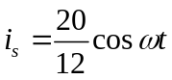, R = 12//45= 12x45/57 = 9.4737 kΩ
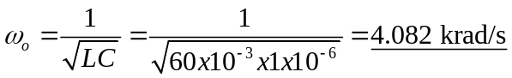 = 4.082 krad/s

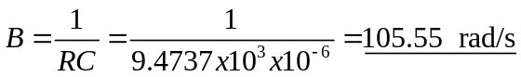 = 105.55 rad/s
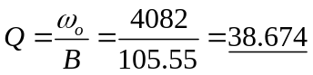 = 38.67

4.082 krads/s, 105.55 rad/s, 38.67

